**Step for List Heroes:**

1. **You can access the heroes module on by going on this page:**

<http://143.198.214.24:2337/admin/plugins/content-manager/collectionType/application::hero.hero>

You should be showing this page:

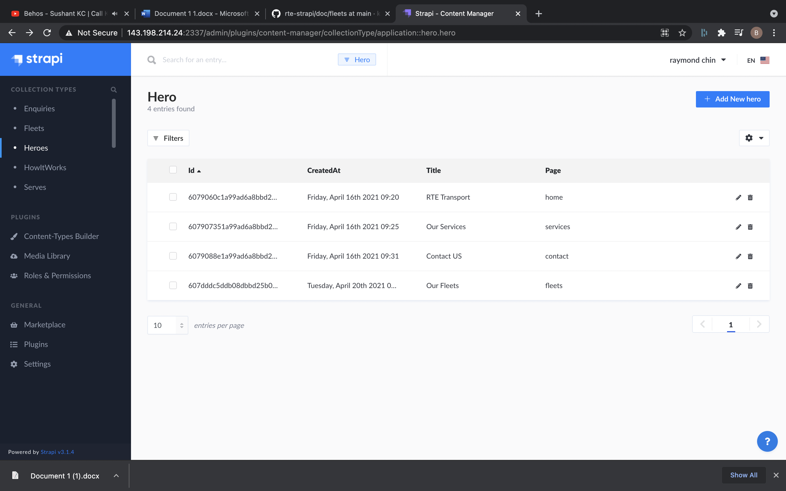

## **Steps for Add new Heroes:**

### **1. Visit link to add new:**

<http://143.198.214.24:2337/admin/plugins/content-manager/collectionType/application::hero.hero/create>

This should be the page shown: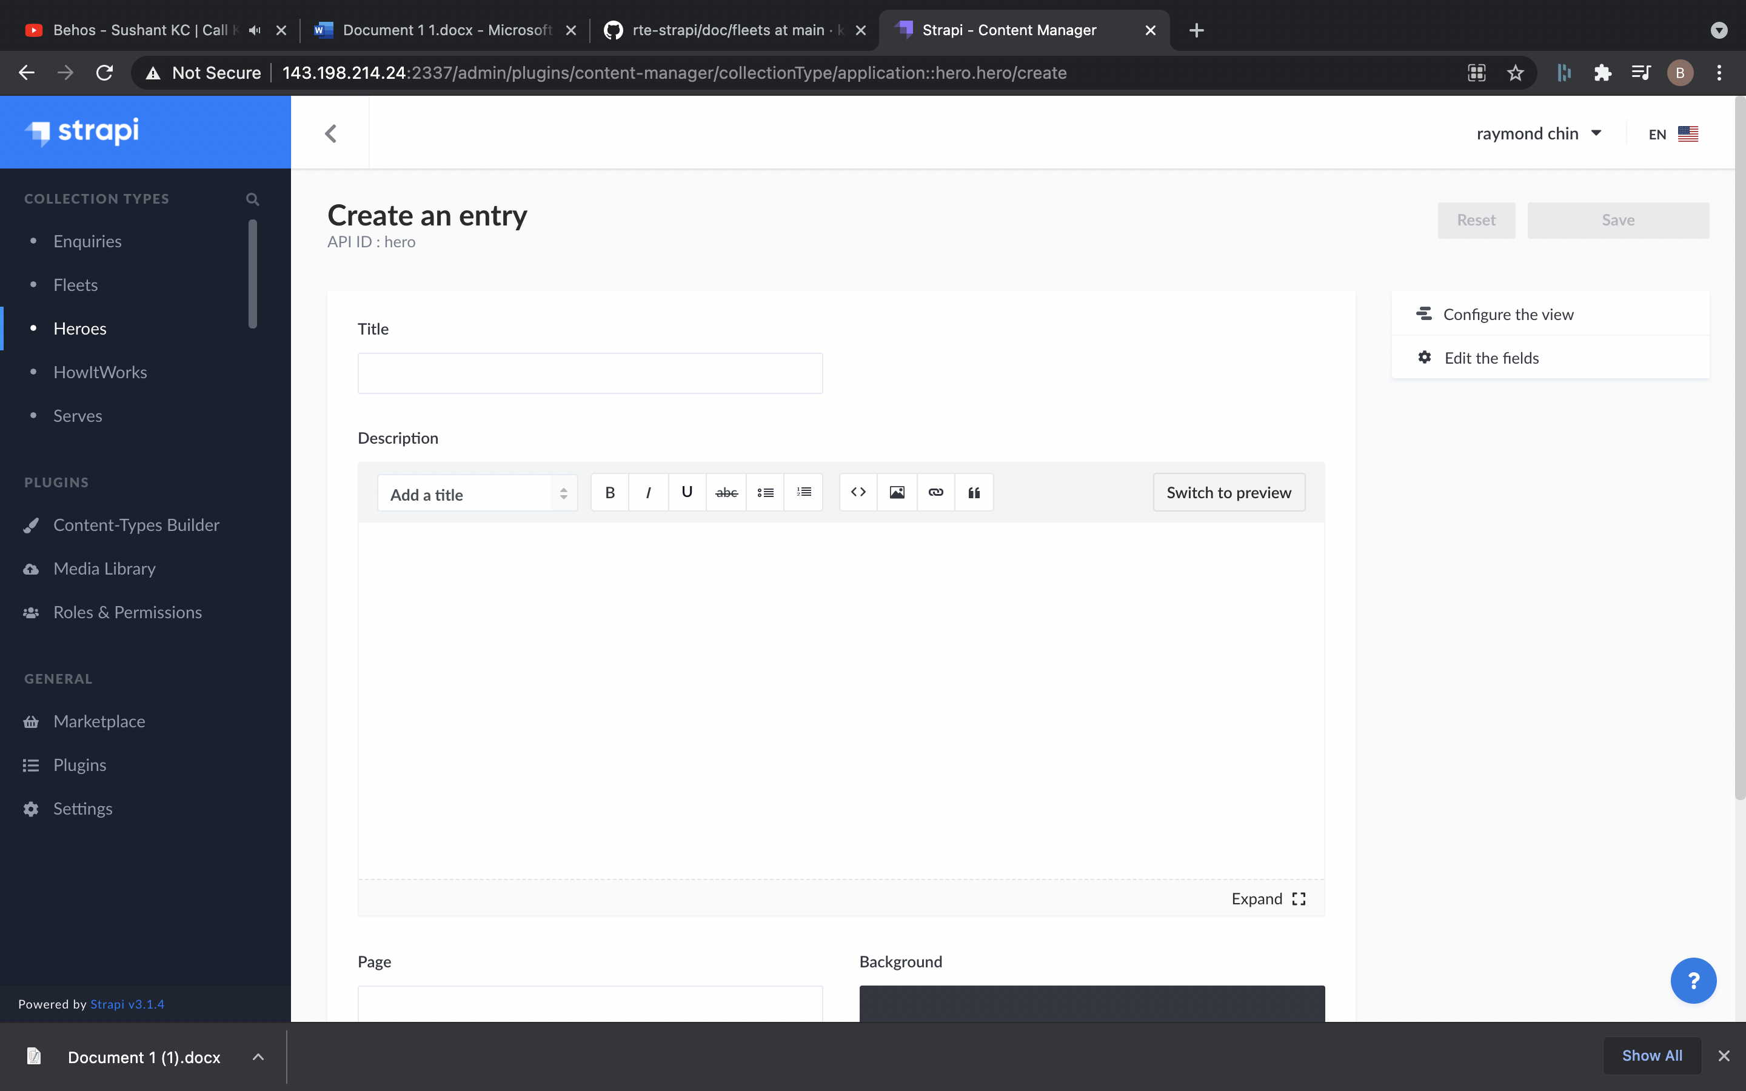

### **2. Add the details for new:**

a. Title: This will be title.

b. Description: This will be the description.

c. Background: This will be the background image for hero, you can add Background by Add More Assets and upload from computer to server.

d. Page: This will be the variable that link which page, the hero belongs to

### **3. Click on save button on top right to save the new fleet.**

## **Steps for delete:**

### **1. Go to List:**

<http://143.198.214.24:2337/admin/plugins/content-manager/collectionType/application::hero.hero>

### **2. Click on data that need to delete:**

It should open the detail, confirm all the details and make sure: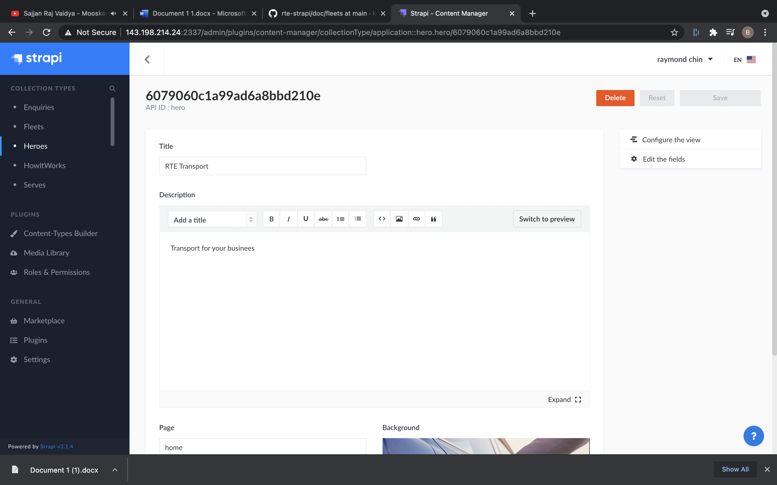

### **3. Click on delete button on top right:**

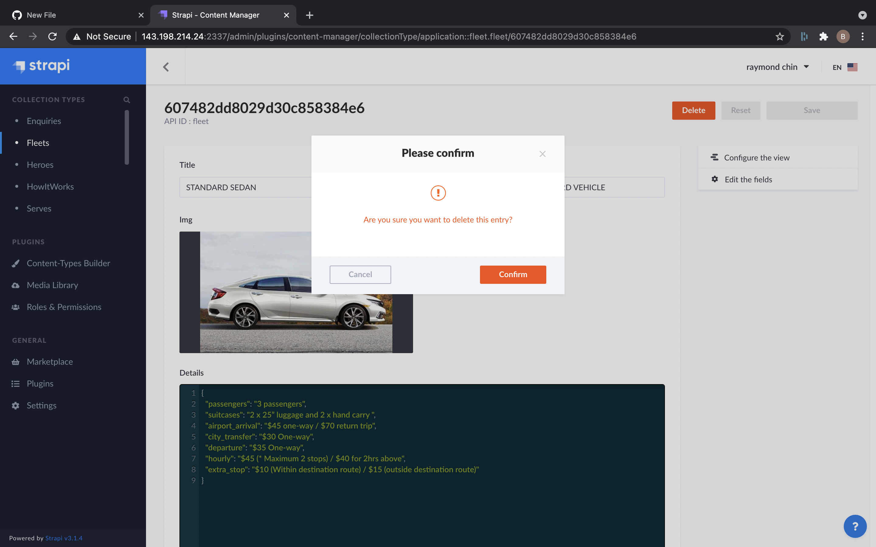

### **4. Click on Confirm to Delete.**

## **Steps for Edit:**

### **1. Go to List:**

<http://143.198.214.24:2337/admin/plugins/content-manager/collectionType/application::hero.hero>

### **2. Click on data that need to edit:**

It should open the detail, confirm all the details and make sure:



### **3. Edit the details :**

a. Title: This will be title.

b. Description: This will be the description.

c. Background: This will be the background image for hero, you can add Background by Add More Assets and upload from computer to server.

d. Page: This will be the variable that link which page, the hero belongs to

### **4. Click on save button on top right to edit.**